%% Edge detection using homogeneity operator

clear all;clc;close all;

img=imread('140828085042_st.png');

% img=rgb2gray(imread('peppers.png'));

[m,n]=size(img);

newimg=zeros(m,n);

for i=2:m-1

for j=2:n-1

newimg(i,j)=max([abs(img(i,j)-img(i-1,j-1)),...

abs(img(i,j)-img(i,j-1)),...

abs(img(i,j)-img(i-1,j)),...

abs(img(i,j)-img(i+1,j+1)),...

abs(img(i,j)-img(i+1,j)),...

abs(img(i,j)-img(i,j+1)),...

abs(img(i,j)-img(i+1,j-1)),...

abs(img(i,j)-img(i-1,j+1))]);

end

end

th=graythresh(img)*max(img(:)); % threshold calculation by otsu method

subplot(121)

imshow(img);

title('Original Image');

subplot(122);

imshow(newimg>th/4);

title('Homogenity Operator Output');

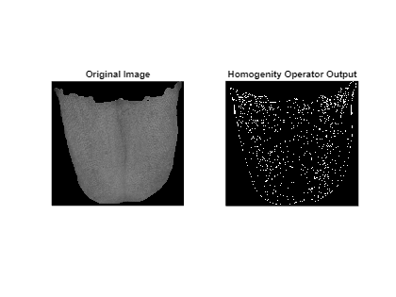

% higher the homogenity factor, better the edge